



**Team Members:**

BASAVARAJ M GOUDAPPANAVAR

**Table of Contents** 

1.Introduction.

2.Visit details.

3.Background Information.

* The technologies and components typically used in data acquisition systems for BRTS bus stops.

4.Need of Self-Powered Data Acquisition System.

* Different natural energy sources that can be utilized to build self-powered data acquisition systems.
* Reason for Choosing Footstep Power Generation**.**
* Flow chart.
* Circuit.
* 3D Model.

5.Case Studies.

* Case Studies of Self-Powered Data Acquisition Systems.
* Analysis of Self-Powered Data Acquisition Systems.

6.Conclusion.

* Reference.

**1.Introduction:**

* The purpose of the industrial visit was to gain insights into the operations and management of Bus Rapid Transit System (BRTS) bus stops. The visit focused on understanding the design, technology, and overall functioning of these modern public transportation facilities. The company we visited specializes in urban transportation infrastructure, with a specific emphasis on BRTS systems. Their expertise lies in designing efficient bus stop layouts, incorporating technology for passenger safety and convenience, and enhancing the overall transit experience.
* During the visit, we had the opportunity to observe the company's data acquisition system, which includes real-time passenger flow monitoring, electronic ticketing systems, and surveillance for security purposes. These technologies are essential for improving the efficiency of BRTS operations and ensuring a seamless commuting experience for passengers, as well as enabling data-driven decision-making for management. One of the main objectives of the visit was to explore the sustainability features of BRTS bus stops, such as energy-efficient lighting, eco-friendly materials, and green infrastructure. Understanding how these elements contribute to reducing environmental impact and promoting sustainable urban mobility was a key focus.
* Additionally, the company's expertise in designing accessible and inclusive bus stops was highlighted during the visit. We learned about features like wheelchair ramps, tactile paving for visually impaired individuals, and digital displays with multi-language support, demonstrating a commitment to making public transport more accessible to a diverse range of users.

**2.Visit Details:**

**Date:**29/04/2024.

**Time**: 2:30pm.

**Duration:** 1hour.

**Location:**



BRTS Bus Stop, Vidyanagar, Hubli.

**Geo tagged photos:**

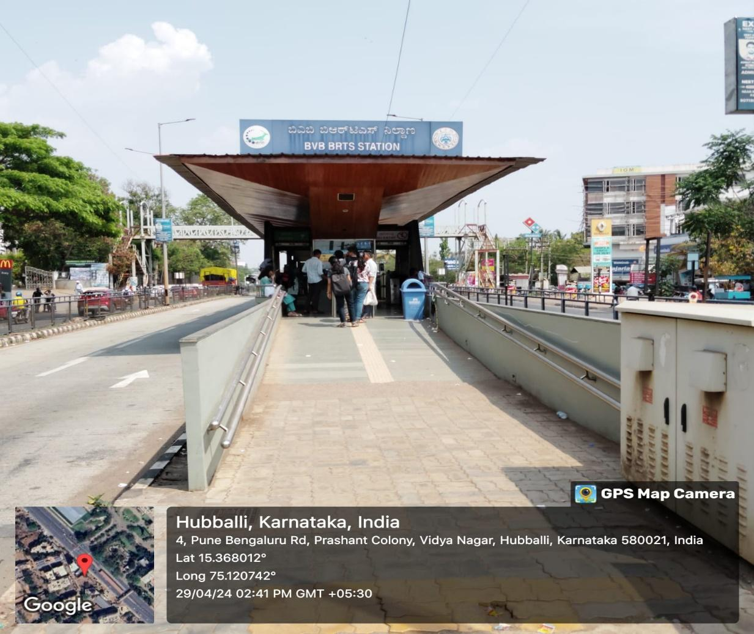

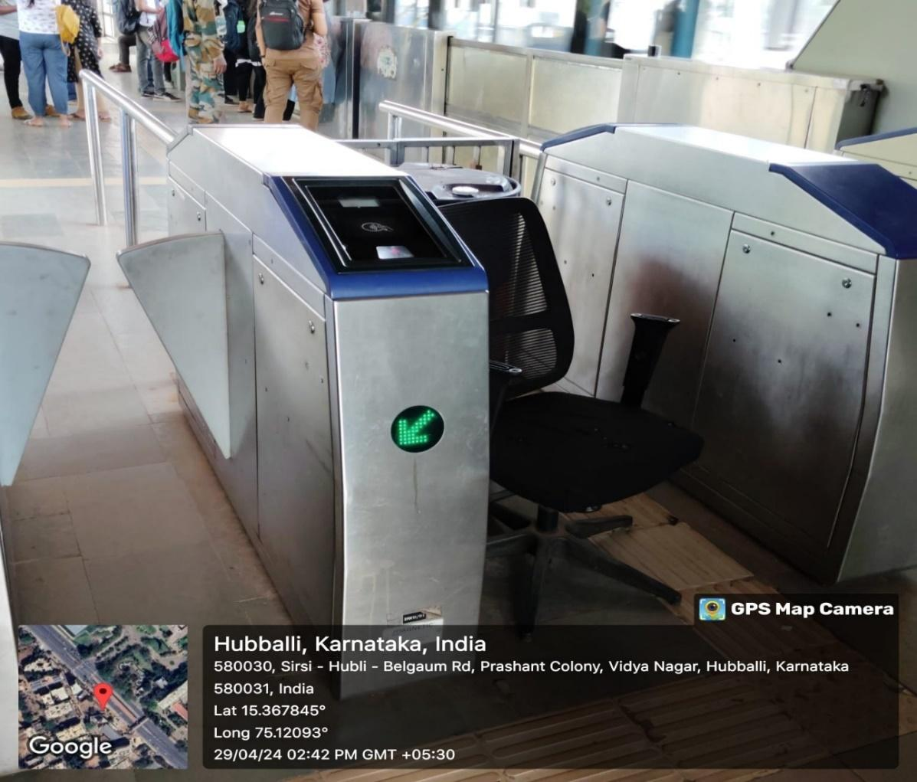

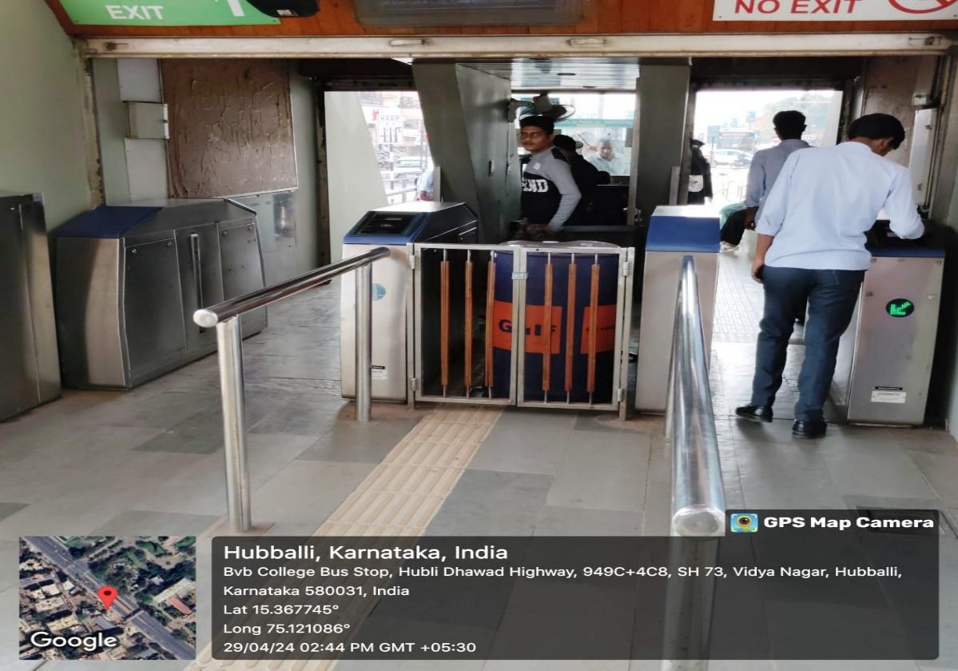**3.Background Information:**

* **Background Information on the Visit to BRTS Bus Stops.**
* Data acquisition systems refer to the technology and processes used to collect, analyse, and manage data in various industries such as transportation, healthcare, agriculture, and more. In the context of the BRTS bus stops visit, data acquisition systems are crucial for monitoring passenger traffic, tracking bus schedules, managing electronic ticketing, and ensuring overall operational efficiency. These systems play a vital role in decision-making, resource allocation, and improving the overall user experience within the public transportation sector.
* **The technologies and components typically used in data acquisition systems for BRTS bus stops include:**
* **Real-time passenger counting sensors:** These sensors are installed at bus stops to accurately count the number of passengers boarding and alighting buses, providing valuable data for route optimization and capacity planning.
* **GPS and tracking systems:** Integrated GPS technology enables real-time tracking of buses, helping passengers to know the exact location and estimated arrival times. This information is also used by transport authorities to monitor fleet performance and ensure adherence to schedules.
* **Electronic ticketing and payment systems:** Smart card readers, mobile apps, and contactless payment terminals facilitate seamless ticketing and fare collection processes, reducing queues and enhancing passenger convenience.
* **CCTV cameras and surveillance systems:** Video surveillance is essential for ensuring passenger safety, monitoring bus stop activities, and investigating incidents or emergencies.
* **Digital signage and information displays:** Dynamic displays provide real-time information on bus schedules, route maps, service updates, and other relevant announcements, improving communication with passengers.
* Performing an energy audit during the visit would involve assessing the energy consumption patterns, identifying potential areas for energy savings, evaluating the efficiency of lighting and HVAC systems, analysing power usage of electronic equipment, and recommending measures to reduce energy waste and improve sustainability at BRTS bus stops.

**4.Need of Self-Powered Data Acquisition System:**

* Self-powered data acquisition systems are essential for BRTS bus stops due to their ability to operate autonomously without relying on external power sources. This ensures continuous data collection and monitoring even in remote or off-grid locations, enhancing the reliability and effectiveness of transportation management. **Different natural energy sources that can be utilized to build self-powered data acquisition systems include:**
* **Solar Energy**: Solar panels can convert sunlight into electrical energy, providing a sustainable and renewable power source for data acquisition systems. This is particularly advantageous in regions with ample sunlight exposure.
* **Wind Energy**: Wind turbines can generate electricity from wind energy, offering another renewable option for powering data acquisition systems. However, the feasibility depends on the local wind conditions and site suitability.
* **Kinetic Energy**: Kinetic energy harvesting systems can capture energy from the movement of buses, passengers, or infrastructure components such as turnstiles or gates. This energy can be converted into electrical power using appropriate technologies.
* **Thermal Energy**: Thermoelectric generators can convert temperature differentials into electricity, utilizing heat sources such as sunlight, ambient air, or waste heat from equipment to power data acquisition systems.
* **Footstep power generation**, also known as kinetic energy harvesting from human footsteps, is a viable and innovative energy source for further implementation in BRTS bus stops. Here's a brief explanation of why this energy resource is chosen and how it can be utilized effectively:
* **Reason for Choosing Footstep Power Generation:**
* **Sustainability**: Footstep power generation aligns with the principles of sustainability by utilizing human movement, a renewable resource, to generate electricity. This reduces reliance on traditional energy sources and promotes eco-friendly practices within the transportation infrastructure.
* **High Foot Traffic Areas:** BRTS bus stops typically experience high foot traffic, especially during peak hours. Harnessing the kinetic energy from the footsteps of passengers can yield significant electricity generation in such busy locations, making it a practical and efficient energy source.
* **Complementary to Solar/Wind Energy:** Footstep power generation can complement other renewable energy sources like solar and wind energy. It provides a continuous and reliable power source even during cloudy days or low-wind conditions, ensuring uninterrupted operation of data acquisition systems at bus stops.
* **Brief Overview of Footstep Power Generation Implementation:**
* **Technology:** Footstep power generation systems utilize piezoelectric materials or electromagnetic induction mechanisms to convert mechanical energy from footsteps into electrical energy. Piezoelectric tiles or pads installed on the ground can generate electricity when compressed by the weight and movement of pedestrians.
* **Location Selection:** High-traffic areas within BRTS bus stops, such as entry/exit points, waiting areas, or pedestrian walkways, are ideal locations for installing footstep power generation systems. These areas ensure maximum utilization of human foot traffic for energy generation.
* **Integration with Data Acquisition Systems:** The generated electricity from footstep power generation can be integrated into the data acquisition systems at bus stops. It can power sensors, lighting, information displays, and surveillance cameras, enhancing the functionality and sustainability of the transportation infrastructure.
* **Cost Consideration:** While the initial installation cost of footstep power generation systems may be higher compared to some other energy sources, the long-term benefits in terms of energy savings, reduced carbon footprint, and enhanced public perception of sustainability justify the investment.
* Overall, choosing footstep power generation for implementation in BRTS bus stops combines environmental consciousness with practical energy solutions, creating a greener and more efficient public transportation environment.
* **Bill of Materials:**

|  |  |  |  |
| --- | --- | --- | --- |
| **Sl.**  **No** | **Name of the Consumable** | **Specifications** | **Quantity** |
| 01. | DC Generator motor | 12V | 01 |
| 02. | Rack | 12cm | 01 |
| 03. | Pinions | 3cmx1cm | 03 |
| 04. | L Clamps | 3x3cm | 06 |
| 05. | Connecting rods | 14x0.5 cm | 02 |
| 06. | Shaft | 11x0.5 cm | 01 |
| 07. | Springs | 8cm | 02 |
| 08. | Screws & Bolts | 50x20mm | 40 |
| 09. | Chain Sprocket | 12cm | 01 |
| 10. | Supporting rods | 14x1cm | 04 |
| 11. | Supporting rods | 10x1cm | 02 |
| 12. | Supporting rods | 22x1cm | 02 |
| 13. | Metal sheet | 22x10cm | 02 |
| 14. | Metal sheet | 14x6cm | 02 |
| 15. | LED’s |  | 04 |
| 16. | Piezoelectric sensors | 35mm | 05 |
| 17. | Diodes | 1N4007 | 05 |
| 20. | Capacitors | 2000uF | 01 |
| 21. | Digital Multimeter |  | 01 |
| 22. | Resistors | 1k ohm | 04 |
| 23. | LCD | 16x2 | 01 |
|  |  | Total (Approx)=INR3500. |  |

* **Flow chart.**
* Mechanical to Electrical Energy using DC Generator Motor.

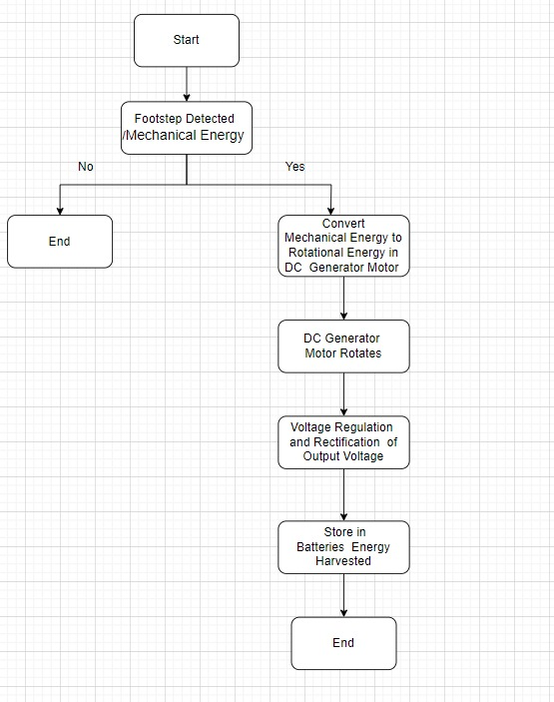

* Mechanical to Electrical Energy by Piezoelectric Sensors.

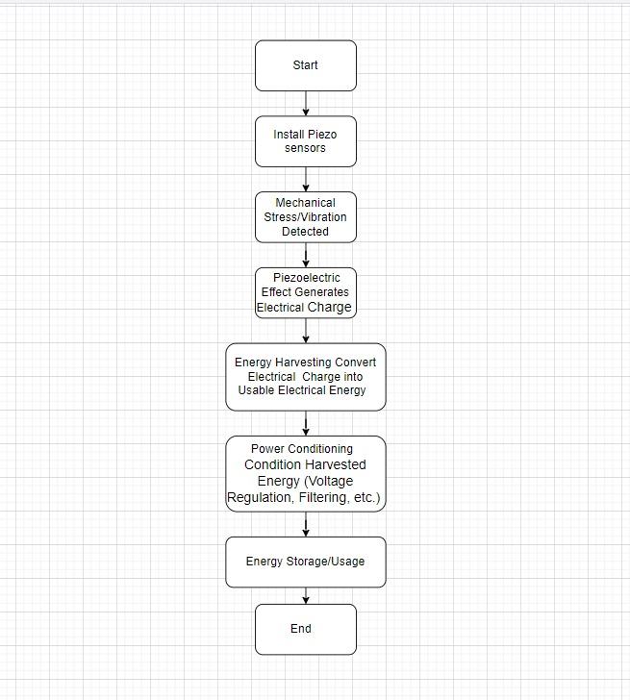

* **Circuit:**

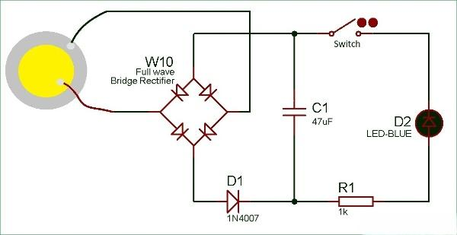

* **3D Model of Foot Step Power Generation System.**

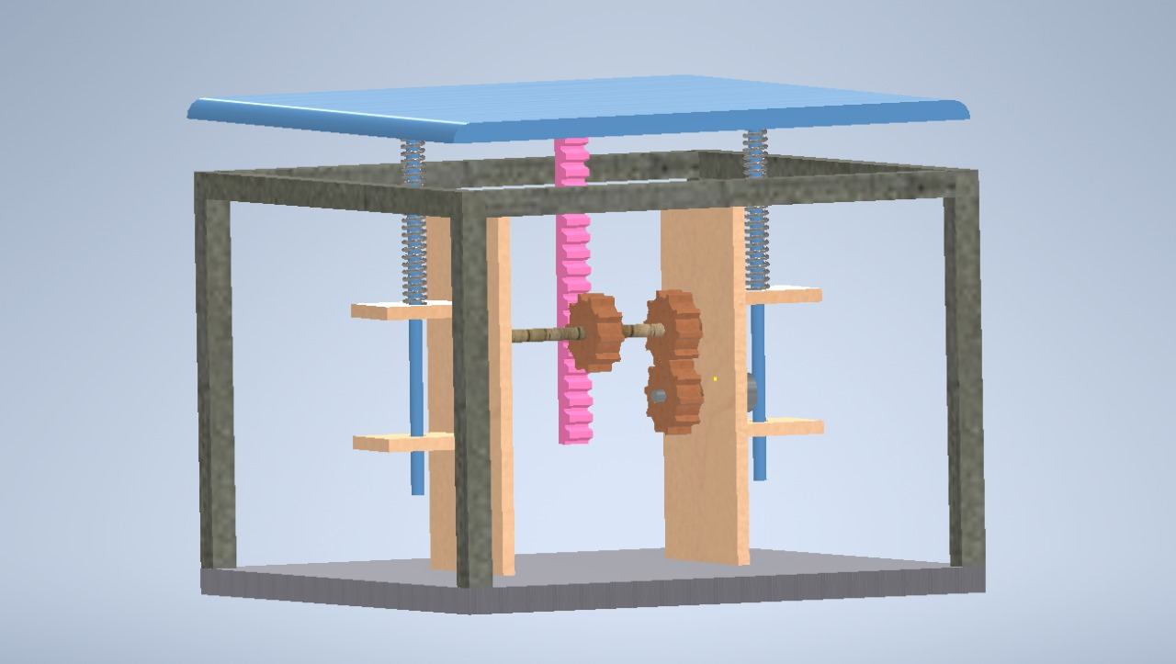

**5.Case Studies:**

* **Case Studies of Self-Powered Data Acquisition Systems:**
* **Solar-Powered Data Acquisition System in Agriculture:**
* Overview: A farm implemented a self-powered data acquisition system using solar energy to monitor soil moisture levels, weather conditions, and crop health.
* Technology: Solar panels were installed to power sensors placed throughout the farm. These sensors collected data on soil moisture, temperature, humidity, and sunlight exposure.
* Performance: The system provided real-time data to farmers, allowing them to make informed decisions about irrigation schedules, pest management, and crop growth optimization.
* Efficiency: By harnessing solar energy, the system operated autonomously without relying on grid power, reducing energy costs and environmental impact.
* Applicability: This system demonstrated the applicability of self-powered data acquisition in agriculture, enabling precision farming and sustainable resource management.
* **Kinetic Energy Harvesting in Smart Buildings:**
* Overview: A smart building utilized kinetic energy harvesting from foot traffic to power data acquisition systems for energy monitoring and building automation.
* Technology: Piezoelectric flooring tiles were installed at key entry points and corridors, capturing energy from footsteps and converting it into electricity.
* Performance: The system powered sensors for occupancy detection, lighting control, HVAC optimization, and energy usage tracking within the building.
* Efficiency: By utilizing kinetic energy, the building reduced its reliance on grid electricity and optimized energy consumption based on real-time occupancy data.
* Applicability: This case study highlighted the potential of kinetic energy harvesting in smart buildings, improving energy efficiency and sustainability while enhancing occupant comfort and productivity.
* **Analysis of Self-Powered Data Acquisition Systems:**
* Performance: Self-powered data acquisition systems have shown reliable performance in various industries, providing continuous data collection and monitoring without disruptions due to power outages or grid dependencies.
* Efficiency: These systems enhance efficiency by utilizing renewable energy sources such as solar, kinetic, or thermal energy, reducing operational costs and environmental impact over time.
* Applicability: Self-powered data acquisition systems are highly applicable in industries like transportation, healthcare, agriculture, and smart infrastructure, where remote monitoring, sustainability, and operational autonomy are essential requirements.
* Challenges: Despite their benefits, challenges such as initial investment costs, maintenance requirements, and technological limitations need to be addressed for widespread adoption and scalability of self-powered data acquisition systems.
* Overall, the case studies and analysis demonstrate the versatility, performance, and potential impact of self-powered data acquisition systems across different sectors, paving the way for a more sustainable and interconnected future.

**6.Conclusion:**

* **Summary of Key Insights from the Industrial Visit:**
* The industrial visit to BRTS bus stops provided valuable insights into the design, technology, and operations of modern public transportation infrastructure.
* We learned about the importance of data acquisition systems in monitoring passenger flow, optimizing bus schedules, and enhancing overall efficiency and safety at bus stops.
* The visit showcased technologies such as real-time sensors, electronic ticketing systems, and surveillance cameras, highlighting the integration of data-driven solutions in transportation management.
* **Reflections on the Significance of Self-Powered Data Acquisition Systems:**
* Self-powered data acquisition systems play a crucial role in modern industries by offering sustainable and autonomous solutions for data collection, monitoring, and analysis.
* These systems reduce dependency on external power sources, enhance operational reliability, and contribute to energy efficiency and environmental sustainability.
* Their applicability extends across various sectors, including transportation, agriculture, healthcare, and smart infrastructure, demonstrating their significance in advancing technological innovation and resource management.
* **Personal Opinions and Recommendations:**
* Based on the visit experience, it is evident that self-powered data acquisition systems hold immense potential for driving efficiency and sustainability in industries.
* I recommend further research and development in optimizing these systems for cost-effectiveness, scalability, and seamless integration with existing infrastructure.
* Collaboration between industry stakeholders, government agencies, and research institutions can accelerate the adoption of self-powered data acquisition systems, leading to a more connected and resilient future.
* In conclusion, the industrial visit deepened our understanding of data-driven solutions in public transportation and underscored the importance of self-powered data acquisition systems in fostering innovation and sustainability across industries.
* **Reference:**

[1] Prof. Namrata J, et.al., “Footstep Power Generation Using Piezoelectric sensors”, International Journal for Research in Advanced Science and Engineering Technology, vol 9, December 2021.